**Installing Atomic Red Team on Windows**

**Prerequisites:**

* **Windows operating system**
* **Powershell (preinstalled in Windows)**

**Step 1: Open google.com and search for the AtomicRedTeam GitHub page.**

* **Use the following link:** [**https://github.com/redcanaryco/invoke-atomicredteam/wiki**](https://github.com/redcanaryco/invoke-atomicredteam/wiki)

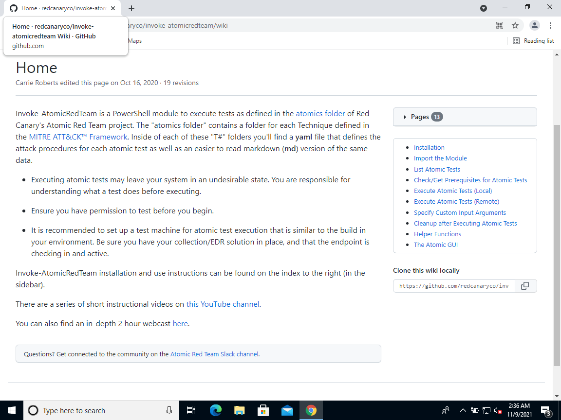

**Step 2: Click “Installation” on the right side.**

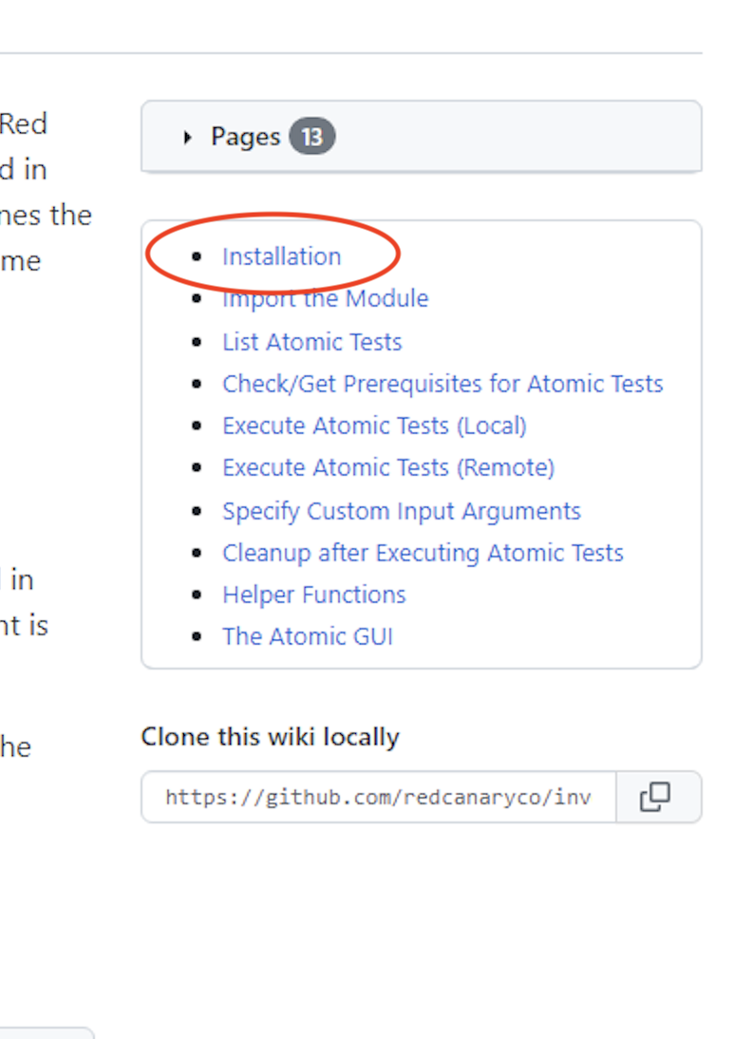

**Step 3: Copy the link under “install execution framework only”**

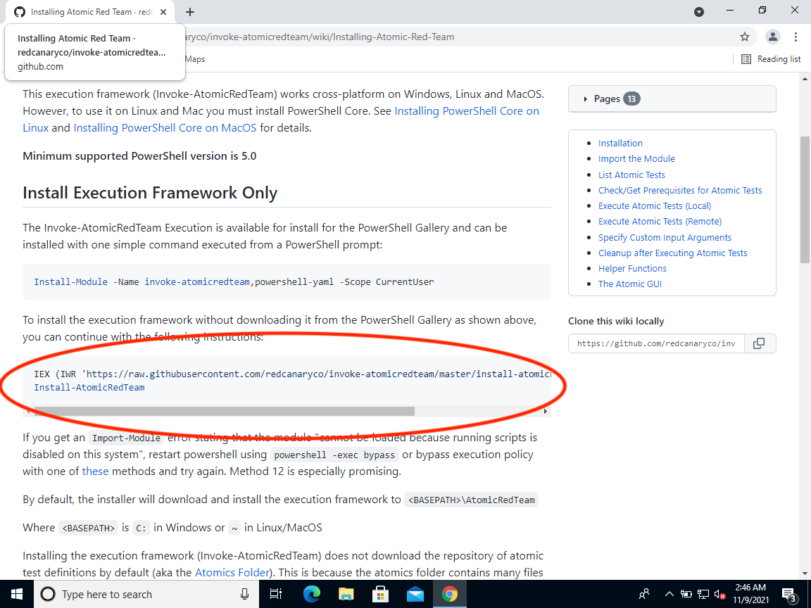

**Step 4: Open Powershell and run it as Administrator.**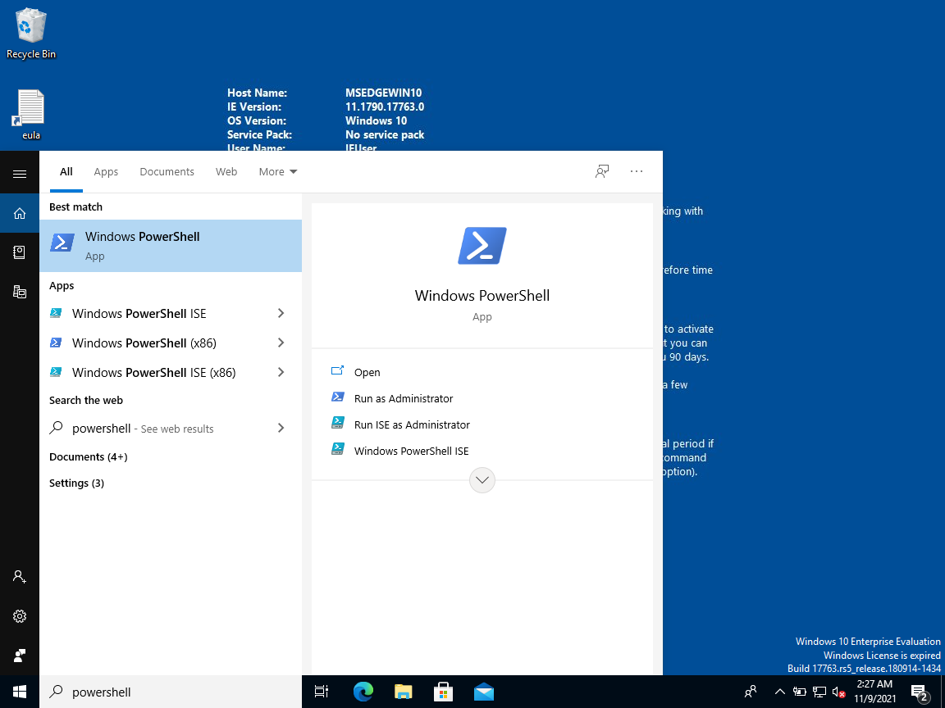

**Step 5: Paste the copied command and run it.**

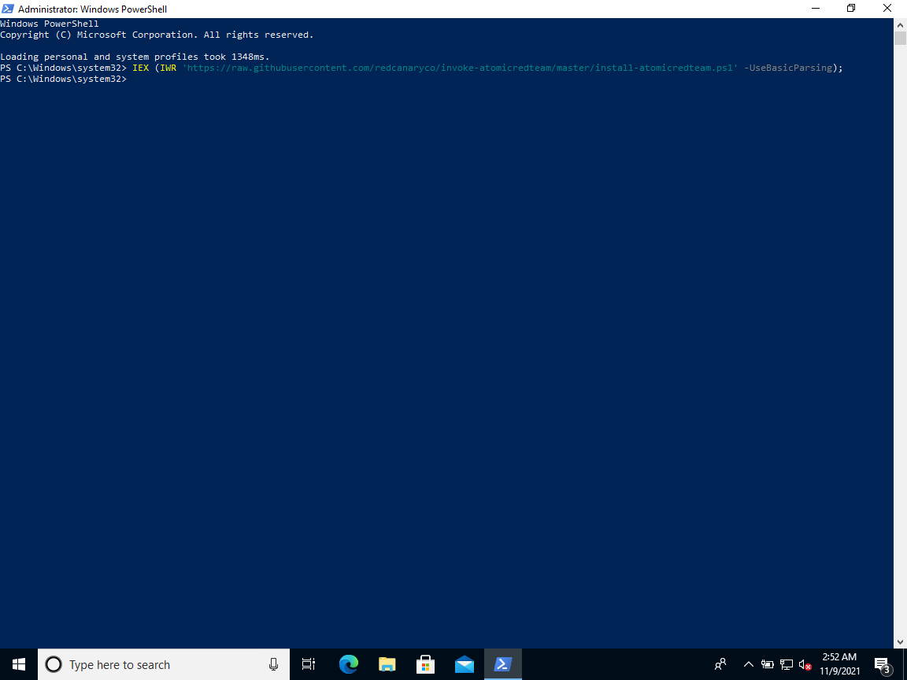

**Step 6: Run “Install-AtomicRedTeam” and after installing it should say “Installation of atomic red team is complete”**

**(In my case it is already installed so it’ll pop out some error or it’ll tell me to use the “-force” command)**

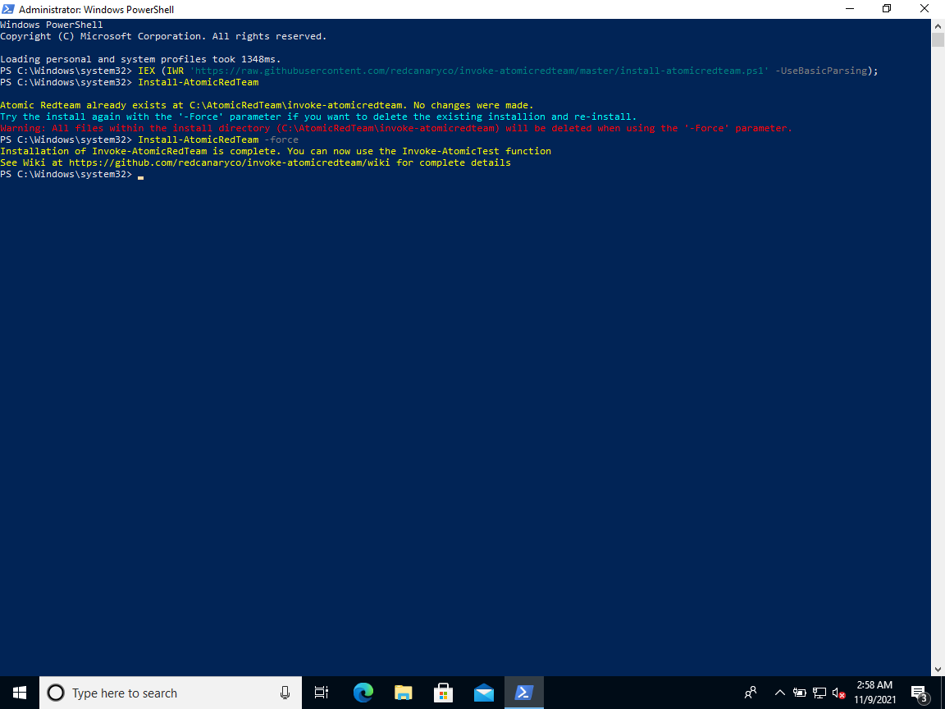

**Step 7: Run “Invoke-AtomicRedTeam -getatomics” After installation it should say “Installation of Invoke-AtomicRedTeam is complete”.**

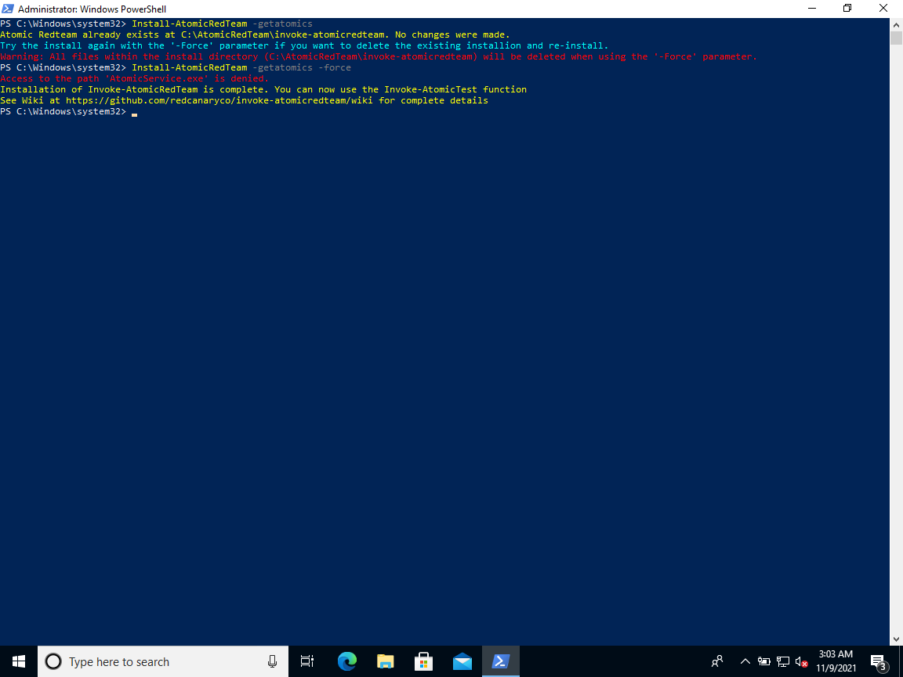

**Step 8: To cross-check whether you’ve installed it correctly, open File Explorer and go to**

**C:\AtomicRedTeam\atomics there you'll find all the atomic tests. Hence you’ve installed Atomic Red Team on Windows**

